WEEK -2 Assignment

Q1. Write a query to display all columns and rows from the customer's table.
QUERY: SELECT * FROM customers;
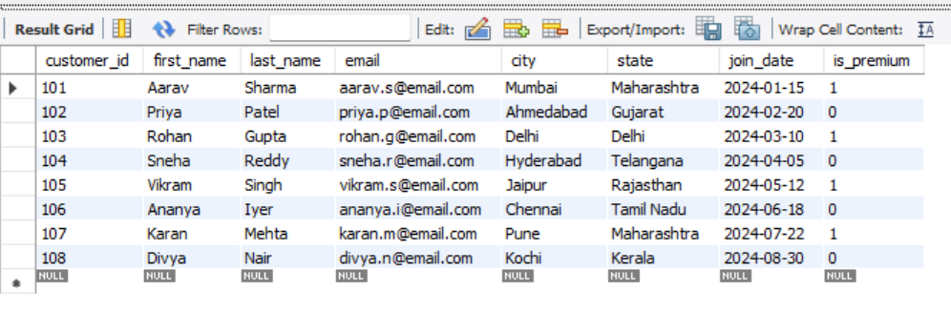

Q2. Retrieve only the first_name, last_name, and city of all customers.
QUERY: SELECT first_name, last_name, city FROM customers;
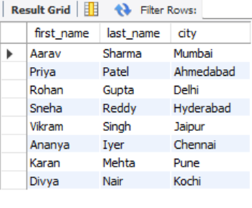
Q3. List all unique categories available in the products table.
QUERY: SELECT DISTINCT category FROM products;
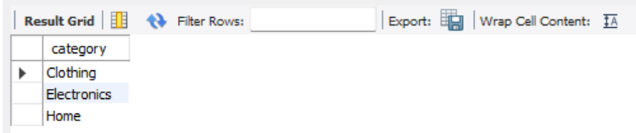
Q4. Identify the Primary Key of each table in the schema. Explain why a Primary Key must be unique and NOT NULL.
Primary Keys:
- Table customers: customer_id
- Table products: product_id
- Table orders: order_id
- Table order_items: item_id
A Primary Key serves as the absolute unique identifier for each row in a database table. It must be unique to prevent duplicate rows and ensure that data records can be cleanly differentiated. It must be NOT NULL because a missing or empty value cannot be used to uniquely identify or point to a specific record, which would break data integrity and foreign key relationships.

Q5. What constraints are applied to the email column in the customers table? What would happen if you tried to insert a duplicate email?
Constraints: The email column has UNIQUE and NOT NULL constraints applied to it.
If you attempt to insert a duplicate email address, the RDBMS will block the transaction and throw a Duplicate entry error because the UNIQUE constraint prohibits identical values in that column.
Q6. Try inserting a product with unit_price = -50. What happens and which constraint prevents it? Write both the INSERT statement and explain the error.
INSERT STATEMENT: INSERT INTO products (product_id, product_name, category, brand, unit_price, stock_qty)
VALUES (209, 'Faulty Item', 'Electronics', 'TestBrand', -50.00, 10);
This insertion will fail and throw a Check constraint violation error. It is prevented by the CHECK (unit_price > 0) constraint defined on the table structure, which guarantees that zero or negative monetary values cannot be written to the database.

Q7. Retrieve all orders with status = 'Delivered'.
QUERY:
SELECT * FROM orders
WHERE status = 'Delivered';
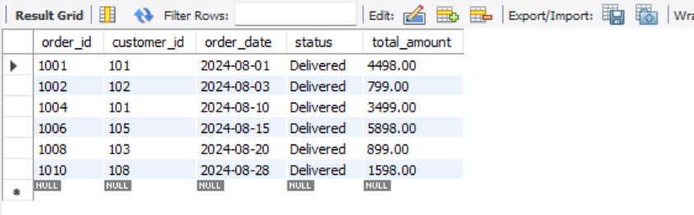
Q8. Find all products in the 'Electronics' category with a unit_price greater than ₹2000.
QUERY:
SELECT * FROM products
WHERE category = 'Electronics' AND unit_price > 2000;
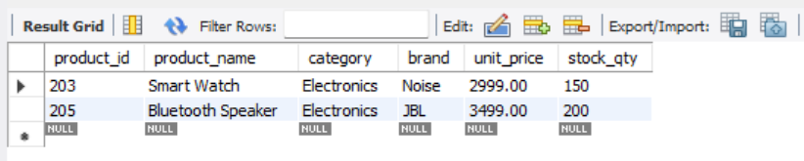
Q9. List all customers who joined in the year 2024 and belong to the state 'Maharashtra'.
QUERY:
SELECT * FROM customers
WHERE join_date BETWEEN '2024-01-01' AND '2024-12-31'
AND state = 'Maharashtra';
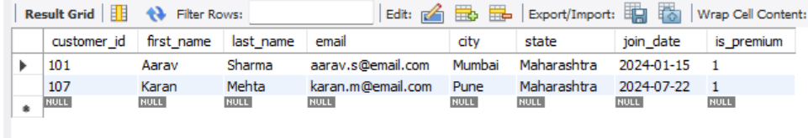
Q10. Find all orders placed between '2024-08-10' and '2024-08-25' (inclusive) that are NOT cancelled.
QUERY:
SELECT * FROM orders
WHERE order_date BETWEEN '2024-08-10' AND '2024-08-25'
AND status <> 'Cancelled';
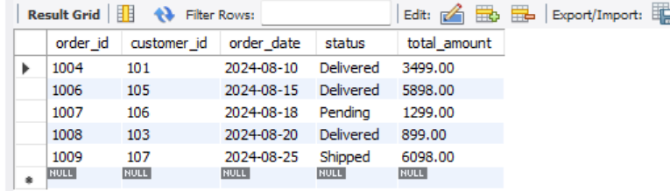
Q11. Explain what the index idx_orders_date does. How would it improve the performance of a query that filters orders by order_date? Write a sample query that would benefit from this index.
The index idx_orders_date creates an ordered, B-Tree data structure based on the values of the order_date column. Instead of performing a slow Full Table Scan ,the database can use this structure to jump directly to the target dates.
QUERY:
SELECT order_id, status, total_amount FROM orders
WHERE order_date = '2024-08-15';
Q12. If you run: SELECT * FROM customers WHERE YEAR(join_date) = 2024; — would the index on join_date be used? Explain why or why not, and rewrite the query to be index-friendly (SARGable).
No, the index will not be used. Applying a function like YEAR() to an indexed column forces the database to compute that function for every individual row, making the query non-SARGable and disabling index optimization.
QUERY:
SELECT * FROM customers
WHERE join_date >= '2024-01-01' AND join_date <= '2024-12-31';
Q13. Count the total number of orders in the orders table.
QUERY:
SELECT COUNT(*) AS total_orders_placed
FROM orders;
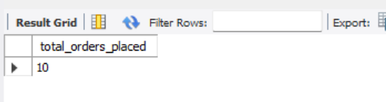
Q14. Find the total revenue (SUM of total_amount) from all 'Delivered' orders.
QUERY:
SELECT SUM(total_amount) AS total_delivered_revenue
FROM orders
WHERE status = 'Delivered';
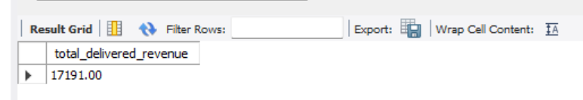
Q15. Calculate the average unit_price of products in each category.
QUERY:
SELECT category, AVG(unit_price) AS average_price
FROM products
GROUP BY category;
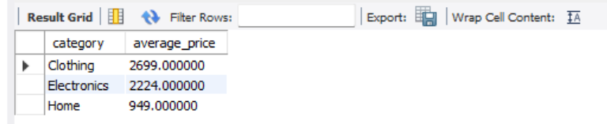
Q16. For each order status, find the count of orders and the total revenue. Sort the result by total revenue in descending order.
QUERY:
SELECT status, COUNT(order_id) AS order_count, SUM(total_amount) AS total_revenue
FROM orders
GROUP BY status
ORDER BY total_revenue DESC;
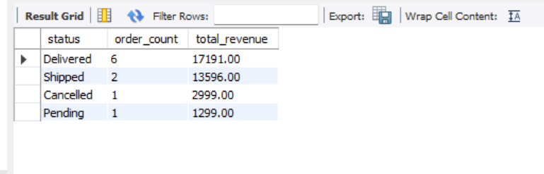
Q17. Find the most expensive (MAX) and cheapest (MIN) product in each category.
QUERY:
SELECT category, MAX(unit_price) AS most_expensive, MIN(unit_price) AS cheapest
FROM products
GROUP BY category;
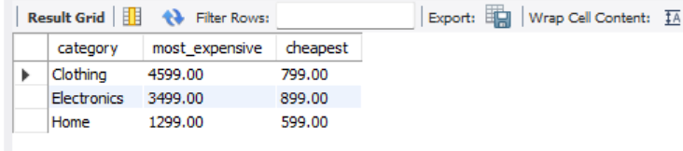
Q18. List all product categories where the average unit_price is greater than ₹2000. (Hint: Use HAVING clause)
QUERY:
SELECT category, AVG(unit_price) AS average_price
FROM products
GROUP BY category
HAVING AVG(unit_price) > 2000;
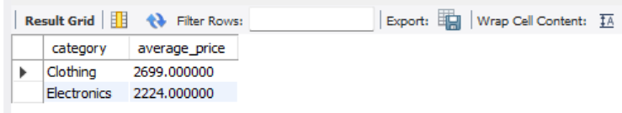
Q19. Write an INNER JOIN query to display each order along with the customer's first_name and last_name. Show: order_id, order_date, first_name, last_name, total_amount.
QUERY:
SELECT o.order_id, o.order_date, c.first_name, c.last_name, o.total_amount
FROM orders o
INNER JOIN customers c ON o.customer_id = c.customer_id;
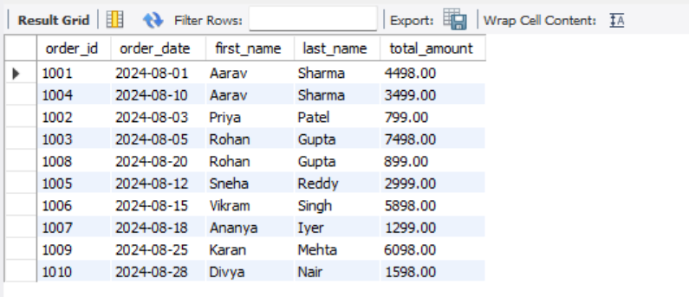

Q20. Using a LEFT JOIN, list ALL customers and their orders (if any). Customers with no orders should still appear with NULL values for order columns.
QUERY:
SELECT c.customer_id, c.first_name, c.last_name, o.order_id, o.order_date, o.total_amount
FROM customers c
LEFT JOIN orders o ON c.customer_id = o.customer_id;
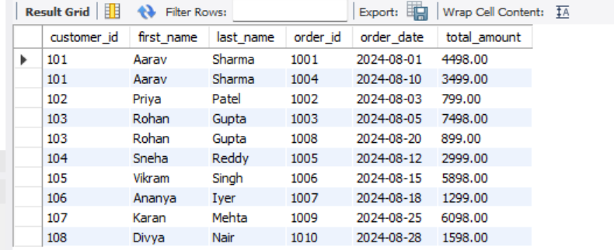

Q21. Write a query using JOINs across three tables (orders → order_items → products) to show: order_id, product_name, quantity, unit_price, and discount_pct for each order item.
QUERY:
SELECT oi.order_id, p.product_name, oi.quantity, oi.unit_price, oi.discount_pct
FROM order_items oi
INNER JOIN orders o ON oi.order_id = o.order_id
INNER JOIN products p ON oi.product_id = p.product_id;
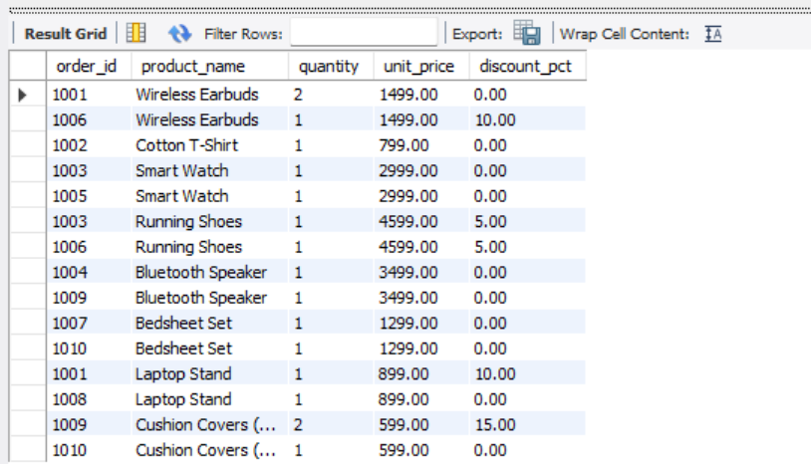
Q22. Explain the difference between LEFT JOIN and RIGHT JOIN with an example from this schema. When would you use a FULL OUTER JOIN?
A LEFT JOIN returns all rows from the left table, plus matched rows from the right table. For example, customers LEFT JOIN orders shows all customers, including those who have placed zero orders. A RIGHT JOIN returns all rows from the right table. For example, customers RIGHT JOIN orders preserves all orders, even if an order isn't linked to a valid customer profile
A FULL OUTER JOIN is used when you want to retrieve all records from both tables, filling in NULL values on either side wherever a match is missing. It is useful for auditing data anomalies, such as finding unmatched items or orphan records across two tables.
Q23. Identify all Foreign Key relationships in the schema. Explain what would happen if you tried to insert an order with customer_id = 999 (which doesn't exist in customers).
Foreign Key :
- orders.customer_id references customers.customer_id.
- order_items.order_id references orders.order_id.
- order_items.product_id references products.product_id.
If you attempt to add an order under customer_id = 999, the engine will block the operation and throw Foreign Key Constraint Violation Error. This happens because referential integrity prevents creating parentless transactions.

Q24. Write a query using CASE to classify products into price tiers:
• 'Budget' → unit_price < 1000
• 'Mid-Range' → unit_price BETWEEN 1000 AND 3000
• 'Premium' → unit_price > 3000
Display: product_name, unit_price, price_tier.
QUERY:
SELECT product_name, unit_price,
CASE
WHEN unit_price < 1000 THEN 'Budget'
WHEN unit_price BETWEEN 1000 AND 3000 THEN 'Mid-Range'
ELSE 'Premium'
END AS price_tier
FROM products;
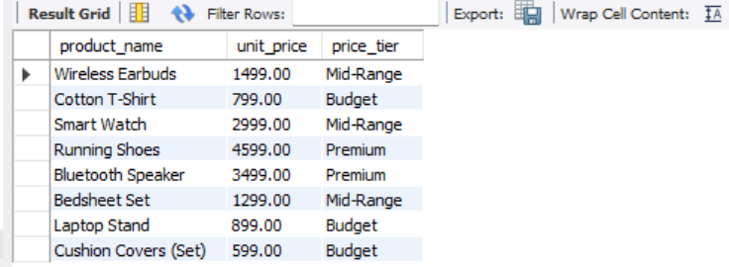

Q25. Using a CASE statement inside an aggregate function, count how many orders are 'Delivered' vs 'Not Delivered' (all other statuses). Display the result in a single row.
QUERY:
SELECT
COUNT(CASE WHEN status = 'Delivered' THEN 1 END) AS Delivered_Count,
COUNT(CASE WHEN status <> 'Delivered' THEN 1 END) AS Not_Delivered_Count
FROM orders;
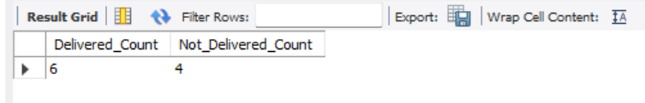
Q26. Explain each letter of ACID:
• A – Atomicity
• C – Consistency
• I – Isolation
• D – Durability
Give a real-world example (e.g., bank transfer) showing why each property is important.

A – Atomicity: Ensures the transaction happens completely or not at all. In a bank transfer, if money is debited from Account A but a system failure occurs before it credits Account B, Atomicity rolls back the deduction entirely so money isn't lost.
C – Consistency: Guarantees a transaction transitions the database from one valid state to another, upholding all schema rules and constraints. For example, a transfer cannot cause a bank account balance to drop below a allowed minimum limit constraint.
I – Isolation: Ensures concurrent transactions execute independently without bleeding intermediate data into one another. If two people transfer money from the same account at the exact same fraction of a second, the transactions execute in isolation to prevent double-spending.
D – Durability: Guarantees that once a transaction is committed, its changes are permanently written to non-volatile storage. Even if the server crashes or loses power a millisecond later, the record of the successful transfer remains intact.

Q27. Write a SQL transaction that does the following atomically:
1. Insert a new order (order_id=1011, customer_id=102, today's date, 'Pending', 1598.00)
2. Insert two order items for that order
3. Update the stock_qty of the purchased products
4. If any step fails, ROLLBACK the entire transaction. Otherwise, COMMIT.
Write the complete BEGIN...COMMIT/ROLLBACK block.

QUERY:

START TRANSACTION;
INSERT INTO orders (order_id, customer_id, order_date, status, total_amount)
VALUES (1011, 102, CURDATE(), 'Pending', 1598.00);

INSERT INTO order_items (item_id, order_id, product_id, quantity, unit_price, discount_pct)
VALUES (5016, 1011, 202, 1, 799.00, 0.00),
(5017, 1011, 202, 1, 799.00, 0.00);

UPDATE products
SET stock_qty = stock_qty - 2
WHERE product_id = 202;

COMMIT;
